**User Guide**

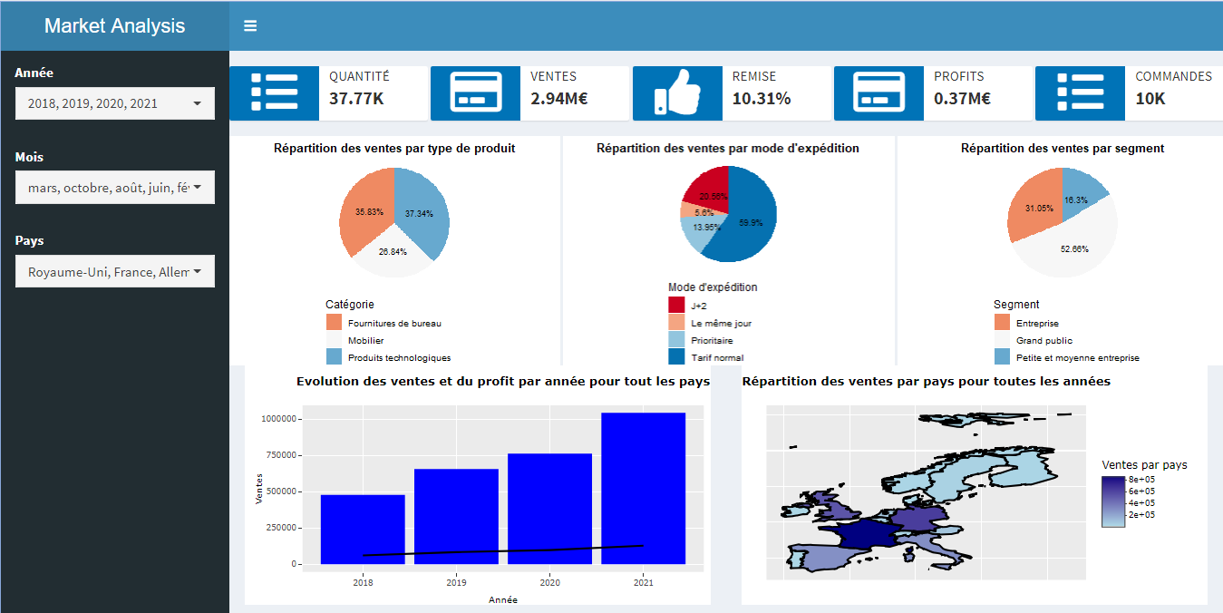

**Outline :**

1. Objective
2. Components
   1. . Filters
   2. . Plots and indicators
3. **Objective :**

The objective of this dashboard is to help the general management team of the sales company to be in touch with their economic data and to take the optimal decisions for their business.

The dataset is a csv file that contains 10 000 rows and 20 columns.

The data available is spread different categories ; we have dates, characters and numerical values.

1. **Components :**

This dashboard is composed mainely of two parts : the first contains the filters from three indicators : years, months and countries. The second part contains five data plots and indicators : 5 KPIs, 3 pie charts, 1 bar chart in dual axis with a line chart and a map.

**2.1 Filters :**

The dashboard can be manipulated using three different filters :

2.1.1. Years : (2018, 2019, 2020 and 2021), one or multiple values selected.

2.1.2. Months : (This filters contains all the months), one or multiple months can be selected.

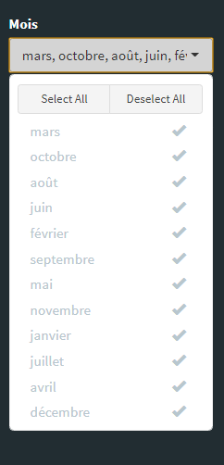

2.1.3 Countries : This filter contains the 15 European countries available in the dataset and the company focuses on.

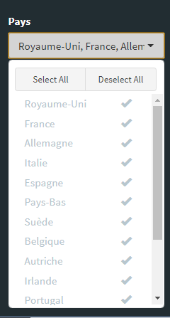

**2.2. Plots and indicators :**

2.2.1. KPIs : we have mainly 5 KPIs that provide the sales, profit, discount, product count and quantity.

The three filters can be applied on the 5 KPIs in order to answer the questions precisely.



2.2.2. Pie charts : We have three pie charts to display different percentages for the categories, segments and delivery modes.

Here only the years filter can be applied so far.

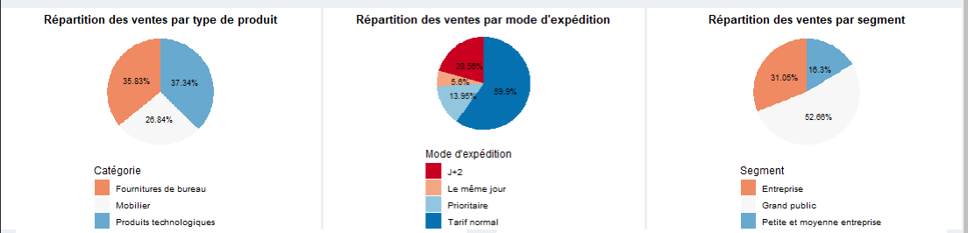

2.2.3. Dual axis graph : this graph contains two plots : a line chart for the profit and a bar chart for the sales with respect to the 4 years and for all the countries.

Plolty library is used to provide the exact value for each year.

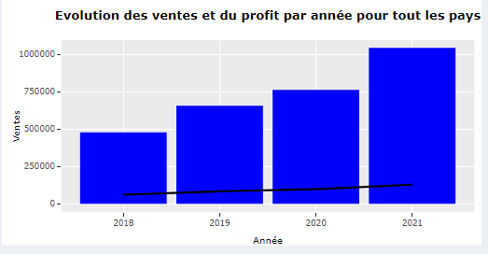

2.2.4. Map : The map is used to represent all the sales for all the countries and all the years. The difference is made by the color, the darker the color the more sales are in the country.

Also here the plolty library is used to provide the exact sales for each country.

